Bouldering
  - Why I like to climb but hate to fall


Contents
Introduction 2
Grades 2
Equipment 3
Shoes 3
Chalk 4
Competitions 4
Safety 4
Injuries 4

Introduction
Bouldering is climbing at hights that don’t require a rope. Crash mats are used to protect climbers from falls. It involves problem solving, technique and building finger and grip strength. There is both indoor and outdoor climbing.

I climb at least once a week and have made reasonable progress over the last year. The community is really friendly and people are always encouraging and willing to offer tips.

Grades
In climbing there are different challenge levels to different climbs, and climbs are given grades so climbers know what challenge to expect.
…
 | Circle | Half-circle | Triangle | Square | Pentagon
Description | Easy, simple climbs | Beginner, may need to think about 1 or 2 moves | More challenging beta, smaller holds. | More challenging, technical climbs, requires some technique | For more experienced climbers
Experience (normal) | Beginner | Beginner – 2 weeks | 2 weeks – 3 months | 3 months – 1 year | 1 year +

Equipment
The time you climb you will probably just rent some shoes and a chalk bag, but once you decide you want to do it regularly you’ll want to buy your own.
..

Shoes
Proper climbing shoes allow your feet to grip the holds. Your whole weight can be supported by tiny fingertip size holds with a good shoe with the correct fit.
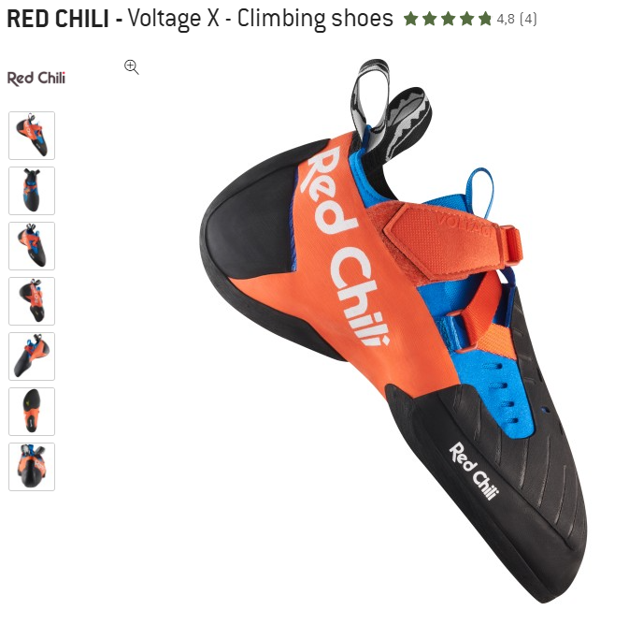

Figure 1 pro climbing show
Figure 2 beginner climbing shoe

Chalk
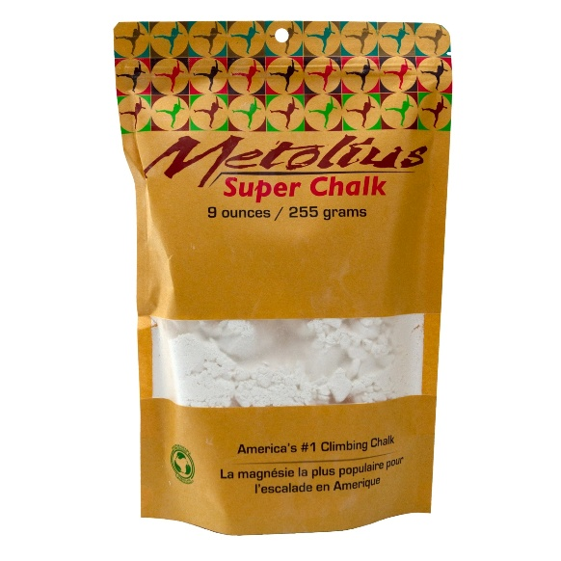

Competitions

Safety

Injuries

